Ever wanted to know the chances of a loved one with an illness surviving to a certain year? How about the chances of a loved one surviving to a certain year in general? Maybe you just want to know how long a product or component you have will last. Well, survival analysis is just the tool to calculate all of these. Survival analysis is just that: an analysis of how long people or things last. At its core, survival analysis revolves analyzing the trends found in the survival curve and hazard curve to determine rates of survival and failure, respectively. Here, I will be primarily discussing what the survival curve is and provide some use cases for the curve.

The survival curve is a continuous curve that maps from times, t, on the x axis, to the probability of a person of thing surviving past that time t, on the y axis. Its computation is very simple; it is 1 – CDF, where CDF is just the CDF of the distributions of durations. For example, a typical survival function would be with the distributions of ages. If we calculate the CDF then take 1 – CDF, we can map a person’s age to the probability they will survive past that age. The same can be said about the age of machinery components or household products. There are four types of survival curve functions which can be seen below.

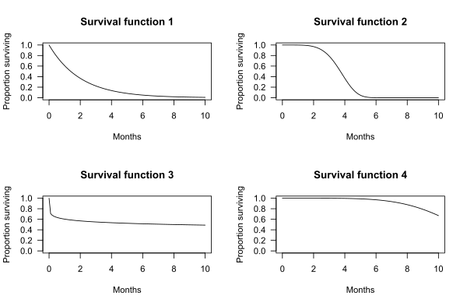

The survival function for human ages tends to follow either functions 1 or 2 depending on the population studied. With current advances in healthcare, though, the probability of survival at a certain age increases, thus pushing the curve in function 2 forward as seen in function 4. Ideally, one would want to achieve function 3, as survival probabilities remain stable and are independent of age. In fact, this is exactly what happens with some biologically immortal organisms such as the hydra, the appropriately named immortal jellyfish, and microorganisms.

Survival curves can also be used to estimate the duration of objects as well as living organisms. I hadn’t realized it before, but I use such curves at my job very frequently. We reference them to find out how long a piece of equipment is expected to last. For example, a distribution of lifetimes for, let’s say, a centrifuge would tell us its mean life expectancy, but the probabilities of the centrifuge actually reaching that age is more meaningful to us because we can easily compare the probability of one brand to another to gauge reliability. I’ve known survival functions as *reliability* functions for most of my life.

Despite their name, survival curves can actually be used on more than just duration distributions. The condition of survival isn’t always about people of things surviving past a certain time. Sometimes, survival functions can be used to find the probability of events occurring, in which case the “survival” duration would be duration until the event occurs. For example, survival curves can be used to estimate the probability that someone will get married at a certain age (which, by the way, doesn’t follow any of the above 4 curves).

References:

https://en.wikipedia.org/wiki/Survival_function

https://en.wikipedia.org/wiki/Biological_immortality

https://towardsdatascience.com/survival-functions-101-bd57fb8be888

https://gravityandlevity.wordpress.com/2009/07/08/your-body-wasnt-built-to-last-a-lesson-from-human-mortality-rates/

My own experiences